**Configuration Drift:**

* Difference between actual and desired state
* In Terraform plan represents drift

**Creating Database in Azure using Terraform**

* We have added the resource to create sql server on azure and applied the template. <https://github.com/asquarezone/TerraformZone/commit/998a87ab478a40a367f9d02c89bee04ddb7561a3?diff=split> for the changes  
  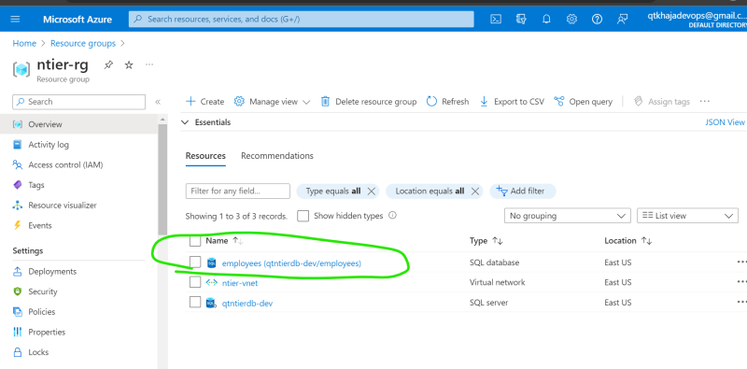

**Terraform graph:** command creates dependency graphs in dot format which can be visualized in Graphviz.[https://dreampuf.github.io/GraphvizOnline/]  
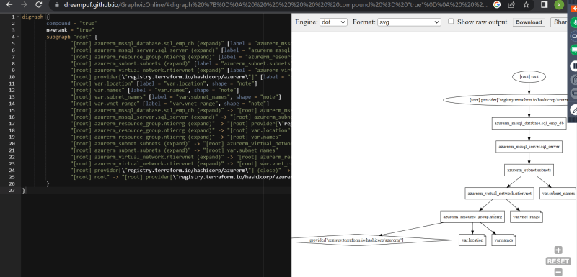

**Create VMs in Azure using terraform**

* Overview of our goal  
  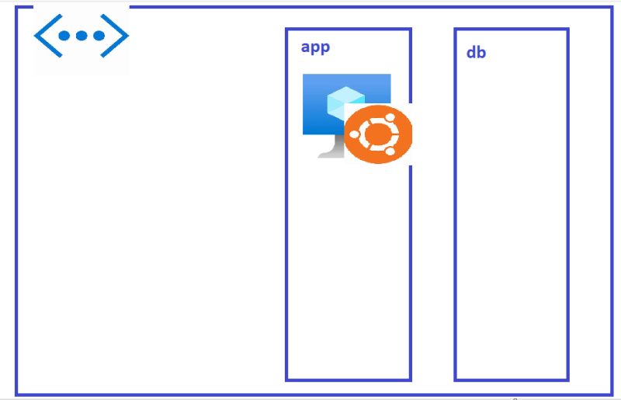
* <https://learn.microsoft.com/en-us/azure/virtual-machines/linux/quick-create-portal?tabs=ubuntu> for manual steps
* <https://github.com/asquarezone/TerraformZone/commit/d2cbaceb9595ef6fc884ed1f9c94f22737fb1078> for the changes.  
  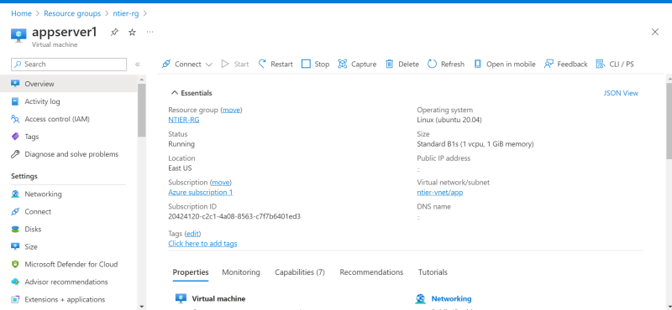
* We have created a vm without public ip and database connectivity between vm and sql is using internet. We will work on this actvities in next session
* Improvements:
  + Try to parametrize using variables and avoid creating too many variables by using object structure. <https://github.com/asquarezone/TerraformZone/commit/3a9b434ae04e2f124b97271755424d765acec857> for changes

**Terraform Datasources**

* Till now we have used terraform to create resources in provider. Terraform can also query the provider for various information
* [Refer Here](https://developer.hashicorp.com/terraform/language/data-sources) for official docs

**Terraform outputs**

* Terraform output is result which would be shown in the stdout
* <https://developer.hashicorp.com/terraform/language/data-sources> for official docs
* Lets display private ip address and database endpoint as outputs <https://github.com/asquarezone/TerraformZone/commit/3c5879a3b0cb89c1b7d9afa86730564fbcbad315> for the changes done  
  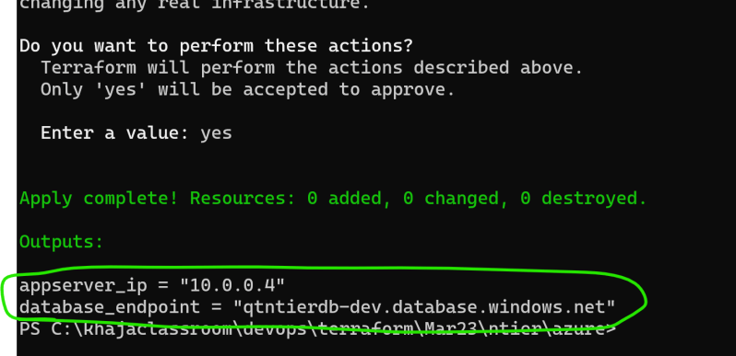  
  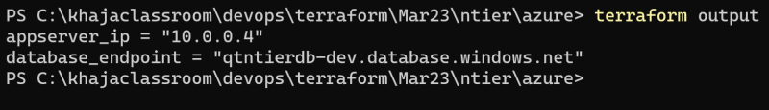

Example: Support I want to find latest AMI, then I would be using data source.